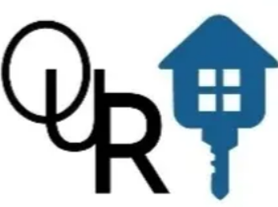Outreach Urban Residential Housing Development, Inc
159 Burke Street
Stockbridge, Ga. 30281
Ph. (877) 894-8317

To: All OUR social media
Sponsors and Donors

I am writing to you on behalf of Outreach Urban Residential Housing Development, Inc.
I wanted to express my heartfelt appreciation for your support and generosity in helping,
us meet our goals OUR organization is committed to supporting the homeless, mental illness, veterans, and youth development program.

As a nonprofit organization, we rely on the support of kind-hearted sponsor’s and supporter like
your company to help us continue our mission. We believe that every individual has the power to make a positive impact on their community and your contributions enable us to make this possible.

With your continuous donation, we will be able to fund various programs that are designed to motivate peoples like you to support us by your donation]. These programs are essential to OUR organization, and we will not be able to deliver them without your support.

We are deeply grateful for your support and wish to thank you once again. Your generosity will
certainly, have a lasting effect on the people and communities we serve. Thank you for being a part of OUR team and sharing OUR vision.

Warm Regards
President / CEO
James Price

www.ourhousingdevelopment.org

